Practice Problem 1

Source Code

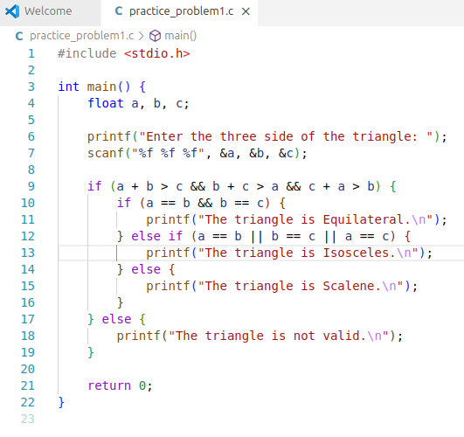

Input & Output
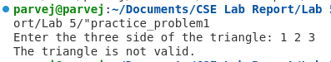
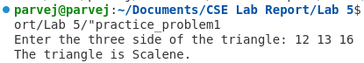
Practice Problem 2

Source Code
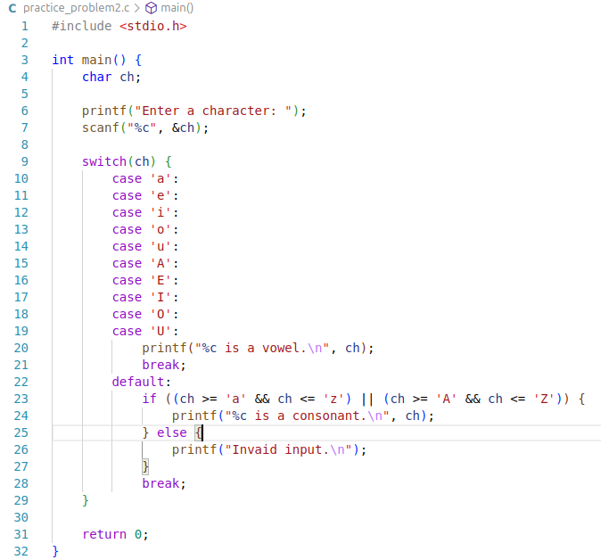

Input & Output
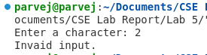
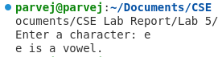
Practice Problem 3

Source Code Input & Output
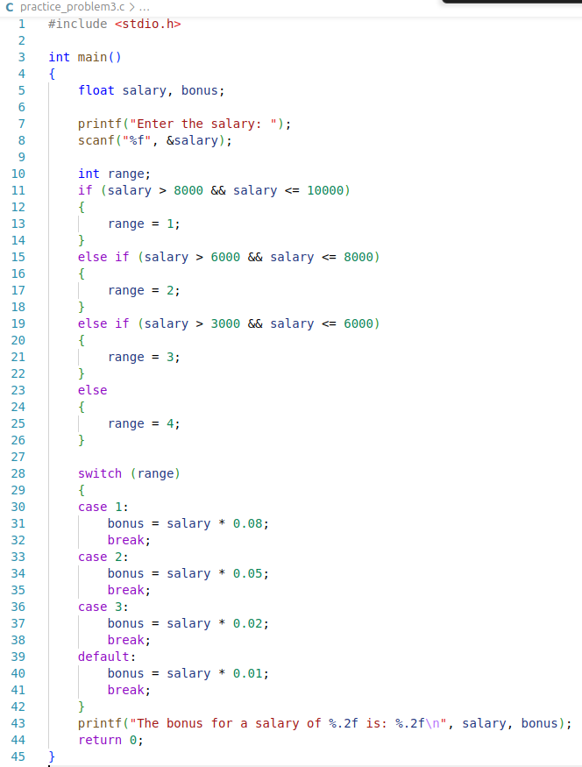
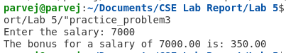

Practice Problem 4

Source Code

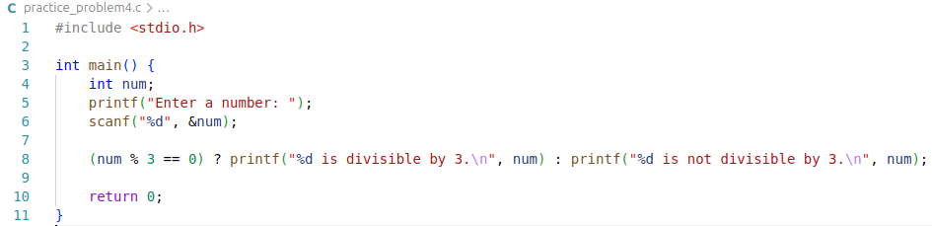

Input & Output

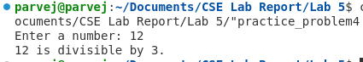
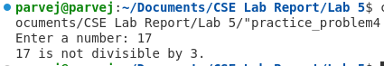
Practice Problem 5

Source Code

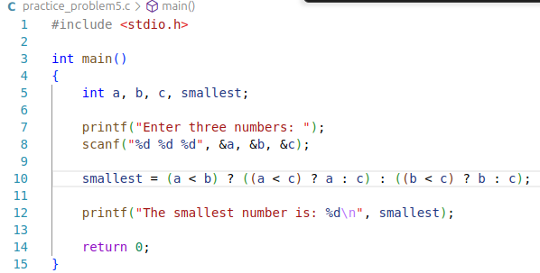

Input & Output

